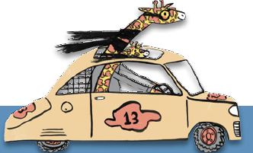
Cruise into Kindergarten Storytime Outline
Early Literacy Tip:
WRITE:

SING:

Basic Info (date, branch, age range, time, title or theme, if applicable):
READ:

TALK:

PLAY:

